**Name: SUDHARSAN S**

**Ex. No: 2 Roll No:231901054**

**CRACK THE HASHES**

**Aim:**

To install and crack the hashed passwords using John-the-Ripper tool in Kali Linux.

**Algorithm:**

1. Install John-the-Ripper on your system using sudo apt install john
2. Prepare the hash file hashes.txt that is to be cracked.
3. Run John-the-Ripper specifying the path to the wordlist.txt and hashes.txt
4. Monitor the cracking process using status option in another terminal

**Output:**

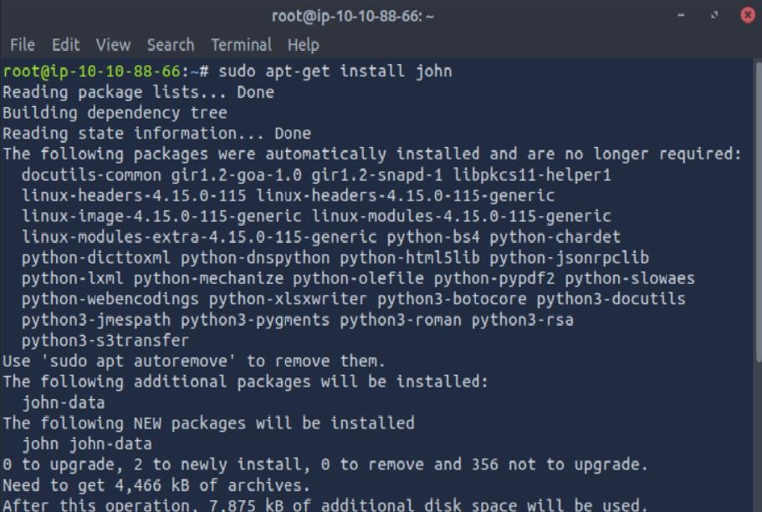

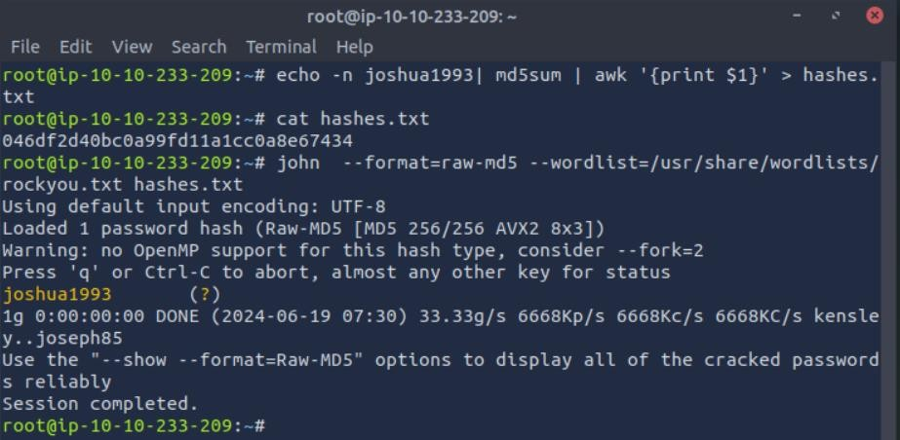

**Result:**

Thus, successfully installed John-the-Ripper tool and cracked the password hashes.